**Project Design Phase**

**Solution Architecture**

|  |  |
| --- | --- |
| Date | 27 June 2025 |
| Team ID | LTVIP2025TMID21127 |
| Project Name | Sustainable Smart City Assistant |
| Maximum Marks | 4 Marks |

**Solution Architecture:**

Solution architecture is a structured design process that ensures alignment between business needs—like improving civic engagement, sustainability reporting, and data accessibility—and technology capabilities. For the Smart City Sustainability Assistant, this architecture integrates AI, natural language processing, data analytics, and user-friendly interfaces to deliver a meaningful solution.

**Goals of the Solution Architecture**

* Solve complex city-level problems like policy inaccessibility, data overload, and language barriers.
* Define the system's core structure and behavior, such as AI pipelines for summarization, speech recognition, and predictive analytics.
* Map features and development phases for iterative delivery (e.g., policy summarization → eco tips → voice Q&A → KPI analysis).
* Establish technical specifications for backend, model APIs, user interaction layers, and data storage**.**

**Example - Solution Architecture Diagram:**

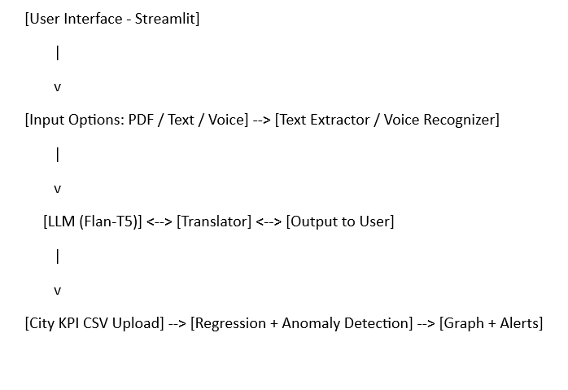

**Figure 1: Solution Architecture and Data Flow of the Smart City Sustainability Assistant**

**Reference:** [**https://aws.amazon.com/blogs/industries/voice-applications-in-clinical-research-powered-by-ai-on-aws-part-1-architecture-and-design-considerations/**](https://aws.amazon.com/blogs/industries/voice-applications-in-clinical-research-powered-by-ai-on-aws-part-1-architecture-and-design-considerations/)